Siddula, Saimanoj

4/8/2016

3 Body Problem

Table of Contents

Problem Statement 2

Set Up 3

Results 4

Test Condition 4

Free Return Initial Conditions: 5

Perihelion Approach 5

Earth Return Approach 6

Conclusion 6

# Problem Statement

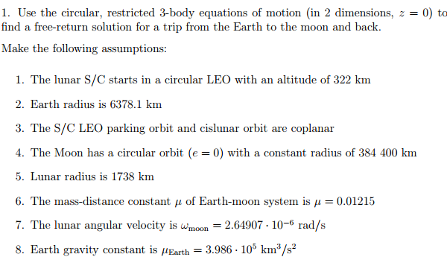

# Set Up

First the equations of the restrictive 3 body equations. This is done with the following:

$${\hat{S}}_{1})\ddot{x}-2\dot{y}-x=\frac{-\left(1-mew\right)\left(x-mew\right)}{{r1}^{2}}-\frac{mew(x+1-mew)}{r2^{2}}$$

$${\hat{S}}_{2})\ddot{y}+2\dot{x}-y=\frac{-\left(1-mew\right)y}{{r1}^{2}}-\frac{mew*y}{r2^{2}}$$

$$r1= \sqrt{{\left(x-mew\right)}^{2}+y^{2} }$$

$$r2= \sqrt{{\left(x+1-,mew\right)}^{2}+y^{2}}$$

Once the equations have been set, they can be adjusted to work with an ordinary differential equation solver with a high order of accuracy.

This allows for the problem to be solved over a length of item. For this to work in the rotation frame of reference it is necessary to transform the ECI coordinate system to the rotating coordinate system this is done through the following steps:

First the vectors of r and v must be converted into the ECI x and y components. This is done through geometric relations.

$r_{X_ECI}=r*cos⁡(pi-gamma)$ $r_{Y_ECI}=r*sin⁡(pi-gamma)$

$v_{x_ECI}=v*cos⁡(\frac{3*pi}{2}-gamma)$ $v_{y_ECI}=v*sin⁡(\frac{3*pi}{2}-gamma)$

These values are then converted to the rotating frame. This is done through scaling the values with respect to the Moon’s velocity and distance from Earth.

$r_{x_Rot}=\frac{r_{xECI}}{r_{m}}+mew_{system}$ $r_{y_Rot}=\frac{r_{yECI}}{r_{m}}$

$v_{x_Rot}=\frac{v_{xECI}}{v_{m}}$ $v_{y_Rot}=\frac{v_{yECI}}{v_{m}}$

Once this set of values have been calculated, they are the initial points of the spacecraft. From here we can input the values into the ODE. These values are in the rotating reference frame so to be able to see what is happening in the ECI frame, the values will need to be transformed back to the ECI system. First the time used in the ODE is the angle in radians. Knowing this will allow for a transformation from the rotation coordinate frame back to the ECI frame.

With the values back to the ECI frame, it can be determined whether the Space Craft met the desired altitude. This was done by taking the differences between the radius of the Earth and Moon and the position of the Space Craft at a given time. Using these values and then determining whether it will achieve the altitude. While making changes several relations were discovered that helped with the optimization. Increasing gamma will help bring the altitudes come closer together, this is done as the third part of the optimization when the delta_v was pushed to a point where it attained desired altitude at the moon but not the Earth.

# Results

## Test Condition

First a test was preformed to ensure that the ODE was working properly and to ensure that the initial conditions were set correctly. This was done by placing the Spacecraft in a stable orbit around the Earth provided that there was no initial delta v and gamma. With these initial conditions the rocket should be stable and keep a similar altitude around the Earth at relatively the same altitude that it started with. As it will be shown using these conditions the Spacecraft did in fact keep a stable orbit around the Earth with relativity the same altitude throughout the orbit.

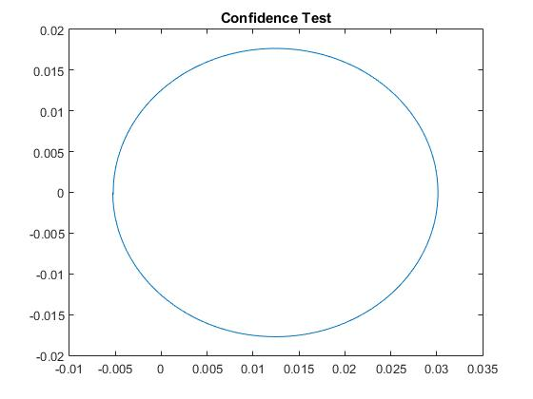

## Free Return Initial Conditions:

For the Free-Return condition it was important to not undershoot or overshoot the Moon. To ensure that this did not happen small changes in V were taken along with small changes in gamma_0. This will allow for a simple estimation as to whether the Spacecraft will reach the moon and back to the Earth. The following values listed below are the initial conditions that were used to reach the Moon and Earth.

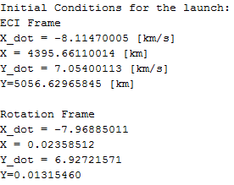

## Perihelion Approach

From calculations the perihelion attained was -254.54 km. The speed of the spacecraft is km/s. The graphs below show the path of the Spacecraft over the length of the launch.

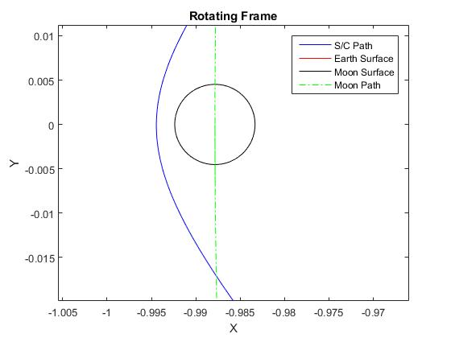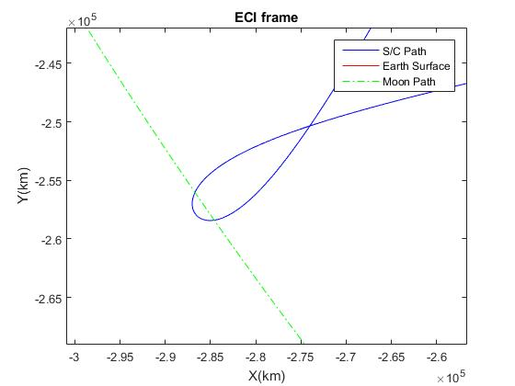

## Earth Return Approach

From the calculations the Earth return altitude was 1174.37km. The graphs below show the patch of the Spacecraft over the length of the launch.

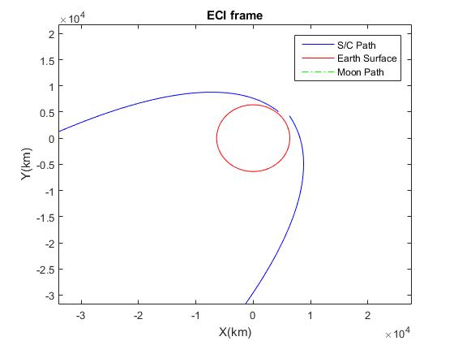

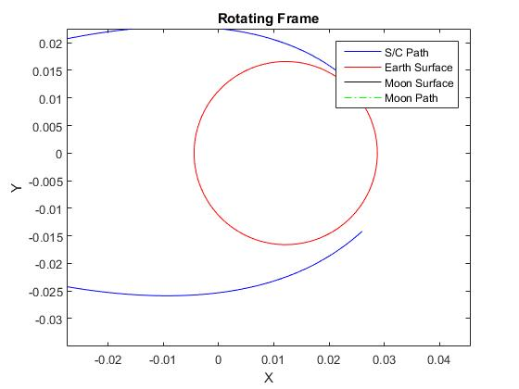

# Conclusion

As the results show for the Spacecraft to be able to perform a free-return trajectory the spacecraft needs to be launched with a delta v of 3.039 km/s and a gamma_0 131 (deg). By using these values the Spacecraft will reach a perihelion altitude of 254km and an Earth returned altitude of 1175km.